**Prelab report 6a**

**Yujian An**

3.2 Equations of motion of the Mechanical system

Under the small-angle approximation sin θ ≈ θ and cos θ ≈ 1, derive the equations of motion (1) and (2) of the inverted pendulum-cart system. In (1), Fa is the force exerted on the cart by the motor.

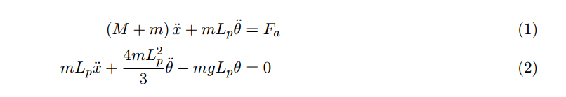

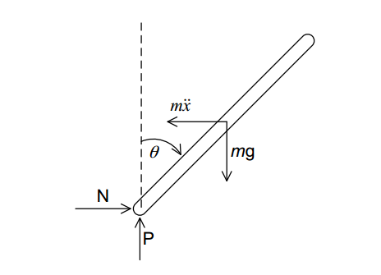 From Newton’s second law. We have F= am

In the question

Assume acceleration=a and angular acceleration=α

Fa= (M+m)*a+m*α*Lp

And we have a = $\ddot{x}$ α= $\ddot{θ}$

Then we have Fa=(m+M) $\ddot{x}$*+m $\ddot{θ}$**Lp, which is (1)

Then calculate the moment of the stick, from the left figure, we have Lp*(m $\ddot{x}$ cosθ-mgsinθ)+I*α=0, where α is the angular acceleration and I is the moment of inertia.

I==mL**2**=mLp**2**. So we have Lp*(mcosθ-mgsinθ)+ mLp**2**.=0

Use linearization cosθ=1 and sinθ=θ, we have Lp*(m-mgθ)+ mLp**2**.=0, which is (2)

3.2 Full System Dynamics of Linearized System

Fa=(m+M) $\ddot{x}$*+m $\ddot{θ}$**Lp (1)

Lp*(m-mgθ)+ mLp**2**.=0 (2)

Fa=V-- (3)

From (1) and (2), we have (M+m+-)+mLp=V- (4)

From (3) we have =θ- (5)

From (4) and (5) we have  
=-θ- +V

Then =(+)θ+- V

So for matrix A, 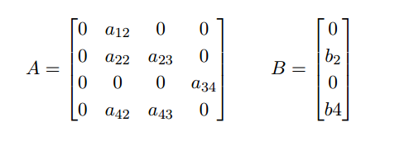

We have a12=1, a22= - , a23=-

b2= , a34 =1, a42=,

a43 = , b4 = -

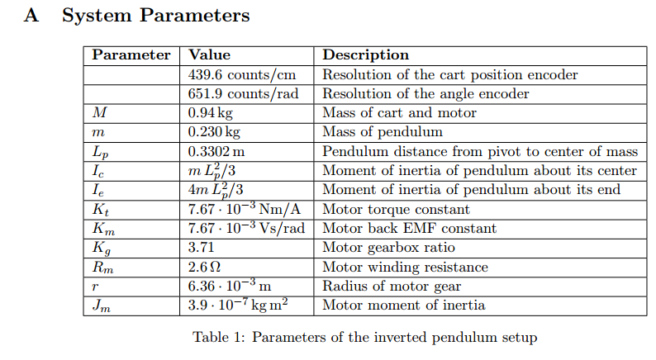

Put the values in ,we get A=[0 1 0 0; 0 -6.81 -1.50 0; 0 0 0 1;0 15.47 25.66 0]

B=[0 ; 1.52 ; 0 ; -3.46]

3.3 Analysis and Controller Design

1. Use MATLAB, we get 4 eigenvalues 0 -9.0525 -3.1232 5.3634, we have one pole on the RHP, so it’s not internally stable, it’s not internally stable, so it can’t be BIBO stable.

2. simulation

F = @(t,x) [x(1);

1.52 - 1.50*x(3) - 6.81*x(2);

x(4);

15.47*x(2) + 25.66*x(3) - 3.46];

tSpan = [0 10];

initialCondition = [pi/2;0;pi/2;0];

[tSol,xSol] = ode45(F, tSpan, initialCondition);

plot(xSol)

plot:

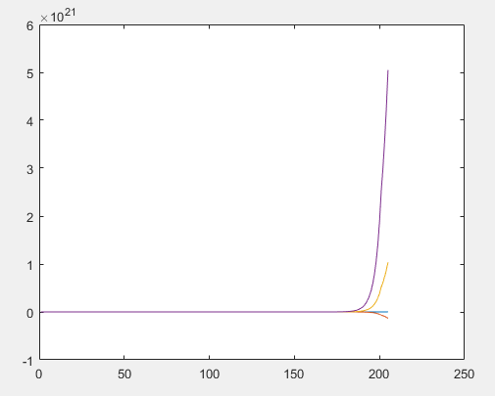

That means in the simulation , the stick will keep rotating as the car goes forward, but actually in the real world’s physical system, we expect the stick become stable at a specific angle. I think that’s because we have things like friction in real world’s physical system, so the stick will lose energy in the process of rotating and finally becomes stable like a tail of the running car, but we don’t have interference like friction in simulation, so the stick can’t be stable and will keep rotating.

3. (a) Ak=[0 1 0 0 ;

-1.52k1 -6.81-1.52k2 -1.50-1.52k3 -1.52k4 ;

0 0 0 1 ;

-3.46k1 15.47-3.46k2 25.66-3.46k3 -3.46k4]

(b) use MATLAB, I get P(k,s)= det(sI-A) to be s4+(6.81-3.46k4+1.52k2)s3+(1.52k1-3.46k3-25.66)s2+(-155-33.93k2)s-33.93k1

(c) Pdes(s)= (s-s1)(s-s2)(s-s3)(s-s4)=s4+7s3+120.02s2+347.7s+440.34

(d) use the P(k,s)=Pdes(s), I get k1=-12.98 k2=-14.72 k3=-47.85 k4=-6.54

Use the command “place”, k1=-12.9795 k2=-14.7230 k3=-47.8456 k4=-6.5363

4. $\dot{x}$ =Akx+BKr, use Laplace transform we get sx(s)=AkX(s)+BKR(s)

The input of system is x, so we only use the first line, so C is [1 0 0 0]

Code:

AK = A - B*K;  
BK = B*K;  
C = [1 0 0 0];  
D = zeros(1,4);  
[num,den] = ss2tf(AK,BK,C,D,1);  
SYS = tf(num,den);  
figure(2)  
bode(SYS)

